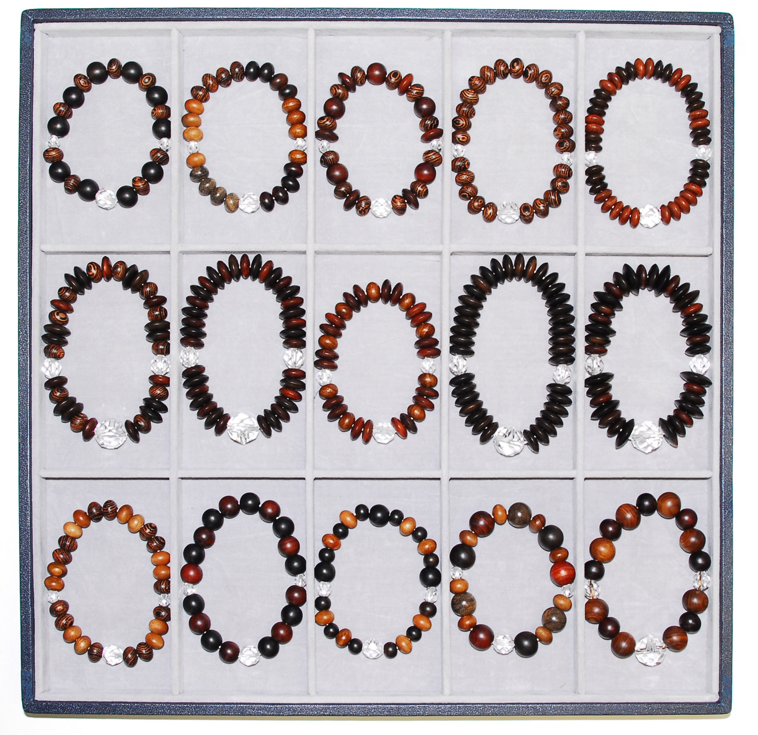
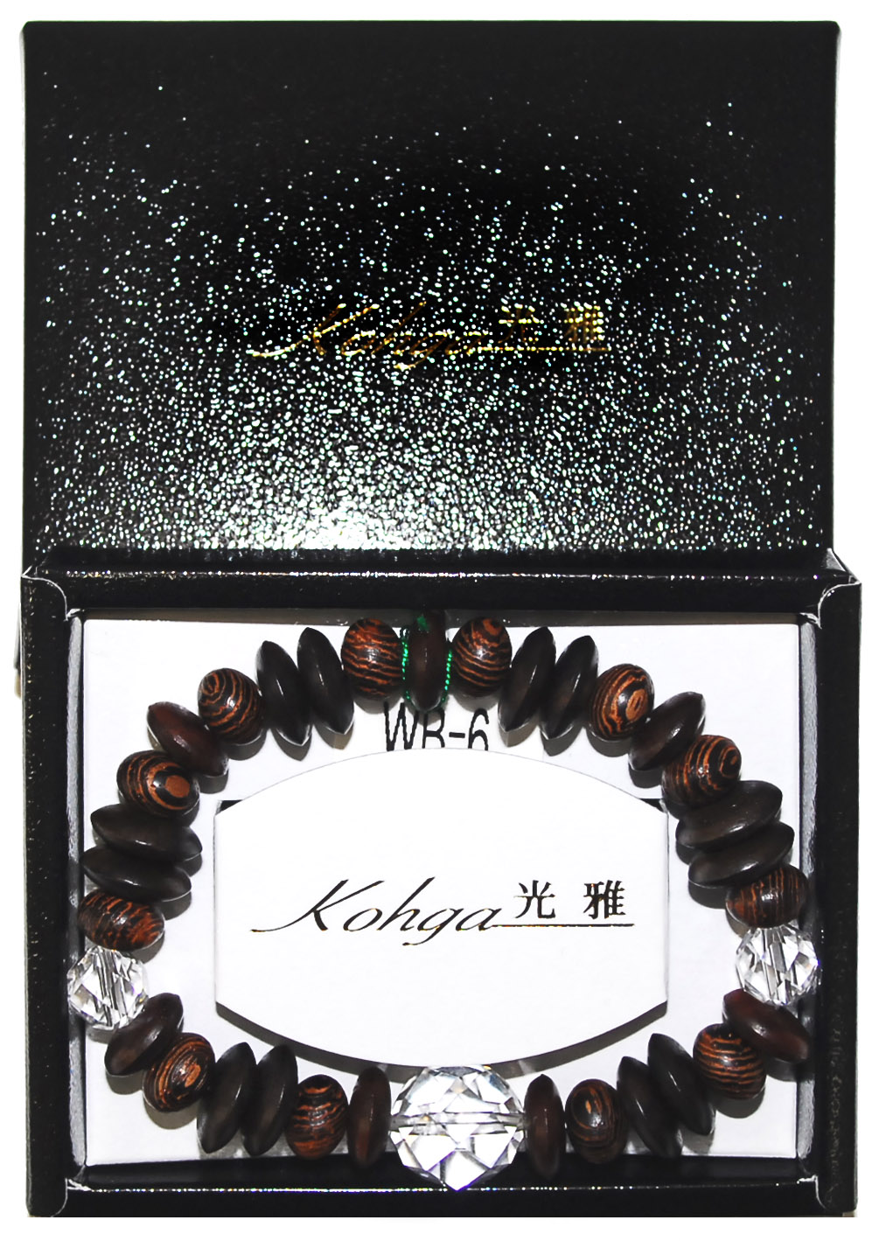
WB-１
WB-2
WB-3
WB-4
WB-5
WB-6
WB-7
WB-8
WB-9
WB-10
WB-11
WB-12
WB-13
WB-14
WB-15
WB-01 | 素引黒檀×素引鉄刀木 |  |  |  |  |  |  |  | \4,000
WB-02 | 素引紫檀×素引桑×素引黒檀×素引鉄刀木×素引桜×シャム柿 |  |  |  |  |  |  | \4,300
WB-03 | 素引鉄刀木×素引紫檀×素引紫檀 |  |  |  |  |  |  |  | \4,300
WB-04 | 素引鉄刀木 |  |  |  |  |  |  |  | \4,000
WB-05 | 素引紫檀×鉄刀木 |  |  |  |  |  |  |  | \4,800
WB-06 | 素引紫檀×素引鉄刀木×素引黒檀 |  |  |  |  |  |  |  | \6,000
WB-07 | 素引紫檀×素引黒檀 |  |  |  |  |  |  |  | \7,200
WB-08 | 素引紫檀×素引桑 |  |  |  |  |  |  |  | \4,800
WB-09 | 素引黒檀 |  |  |  |  |  |  |  | \7,200
WB-10 | 素引黒檀×素引黒檀×素引紫檀 |  |  |  |  |  |  |  | \7,200
WB-11 | 素引鉄刀木×素引桜 |  |  |  |  |  |  |  | \4,300
WB-12 | 素引黒檀×素引紫檀 |  |  |  |  |  |  |  | \4,000
WB-13 | 素引黒檀×素引桜×素引黒檀 |  |  |  |  |  |  |  | \4,300
WB-14 | 素引黒檀×素引桜×シャム柿×素引紫檀 |  |  |  |  |  |  |  | \4,300
WB-15 | 素引栴檀×素引紫檀 |  |  |  |  |  |  |  | \4,800

